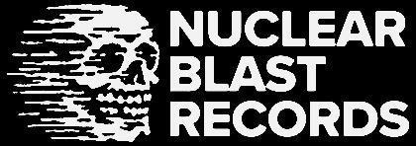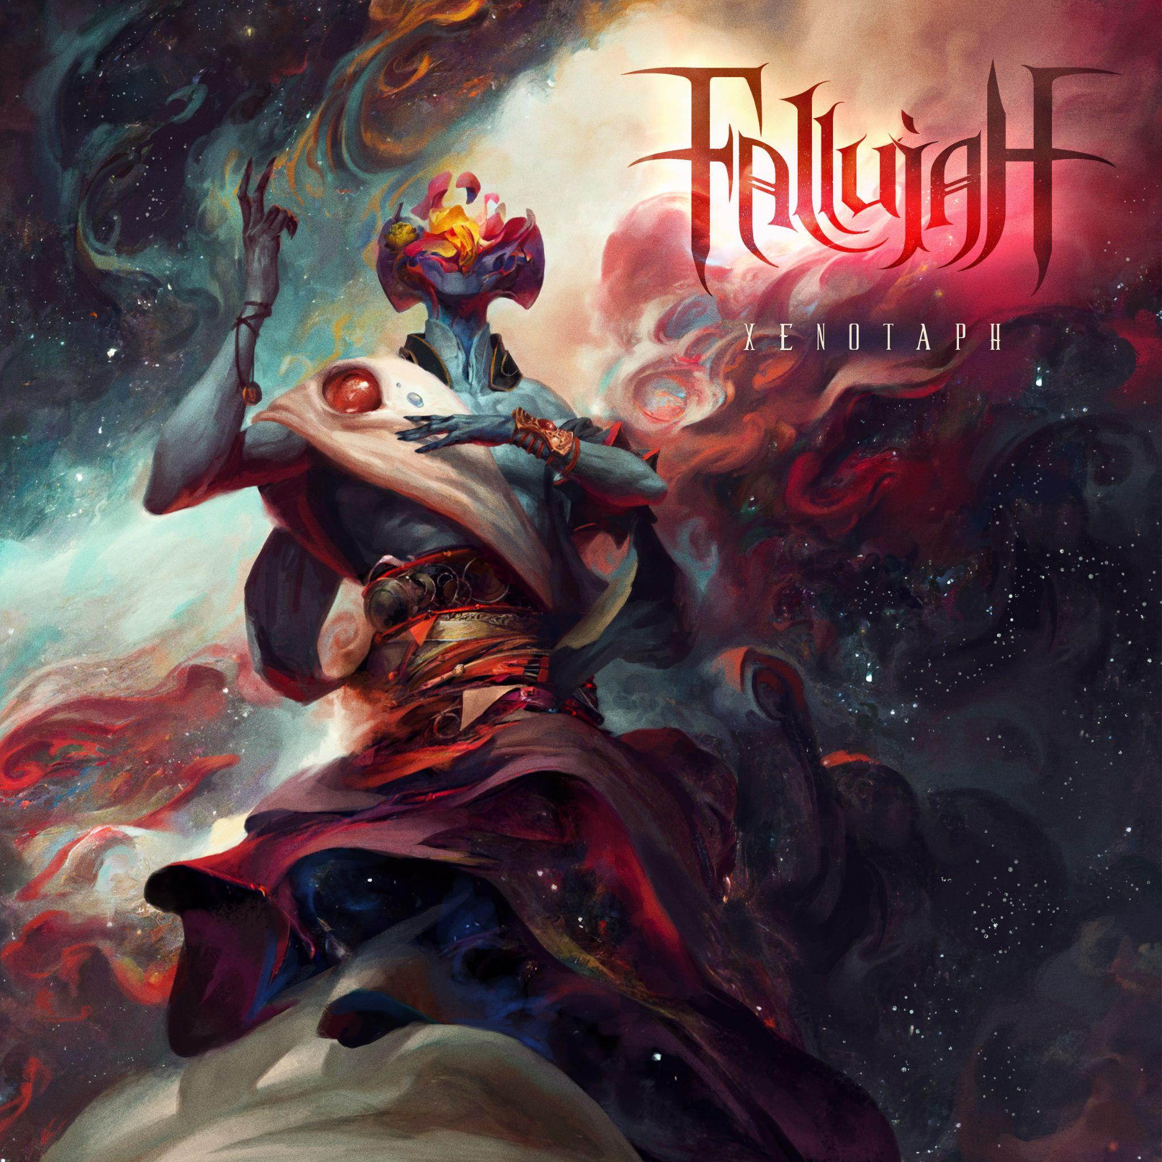

**FALLUJAH**

*Xenotaph*

*Release Date: June 13, 2025*

| **Line up:** | **FALLUJAH online:** |
| --- | --- |
| **Kyle Schaefer | Vocals, Programming**  **Scott Carson | Guitars**  **Sam Mooradian | Guitar**  **Evan Brewer | Bass**  **Kevin Alexander | Drums** | www.facebook.com/fallujahofficial/  www.instagram.com/fallujahsf/  www.x.com/Fallujahbayarea  www.youtube.com/@Fallujah |
|  |  |

Tech-metal outfit **FALLUJAH** expand horizons and solidify their position as one of America’s most exciting artists on their new album, ***Xenotaph***, through **Nuclear Blast**. The Bay Area-based quintet’s confidence in the lineup that made their previous album, ***Empyrean*** (2022), such a resounding success—earning high marks from Metal Injection, New Noise, and Guitar World—has been reconfigured slightly, with guitarist **Sam Mooradian** (INHALE EXISTENCE, SAM MOORADIAN) and drummer **Kevin Alexande**r (DISEMBODIED TYRANT. BROUGHT BY PAIN) bringing their jaw-dropping musical proficiency to the fold, as vocalist Kyle Schaefer, guitarist **Scott Carstairs**, and bassist **Evan Brewer** enter a new chapter with **FALLUJAH**. Moored by singles ‘**Kaleidoscopic Waves**,’ ‘**Labyrinth of Stone**,’ and ‘**Step Through the Portal and Breathe**,’ ***Xenotaph*** is **FALLUJAH** personified, reinvigorated, and re-imagined.

“*Having numerous self-sufficient writers in the band who all agreed on a shared vision allowed us to work as a team to make sure every song was intense, detailed, and dynamic but not overbearing in any aspect, at least to our tastes*,” **Carstairs** says. “*We spent many hours trying out different arrangements and had a goal from the beginning to keep the song structures fast-paced and dense with tons of different parts in each song. We also tried to push the music in a simultaneously more melodic and more technical/progressive direction—even crazier riffs and solos balanced out by atmospheric moments and more prominent clean vocal hooks*.”

As a details-oriented record ***Xenotaph*** benefits from moments of low tension, atmospheric delight, and Schaefer’s winged clean vocals. This dynamic isn’t particularly new to Fallujah, but the group spent considerable time honing what each song needed—from blast-laden speed runs and jazz-fusion solos to vocal restraint and brutality—which resulted in a brighter, more exhilarating experience. Musically, it truly feels like the listener is embroiled in the album’s sci-fi concept and Peter Mohrbacher’s stunning cosmogonic cover art, which is aesthetically in line with his previous covers (***Dreamless*** and ***Empyrean***) for **FALLUJAH**. Close encounters with ‘**Step Through the Portal and Breathe**’, ‘**Labyrinth of Stone**,’ and ‘**Kaleidoscopic Waves**’ spark wonder and stimulate the soul.

“***‘Kaleidoscopic Waves****’ was the first song we began working on,”* recalls **Schaefer**. *“The song changed a lot before it ended up in its current form. ‘In Stars We Drown’ came together the most quickly, and was the first song I wrote vocals for. The last song we completed together was the title track ‘Xenotaph,’ which was also the most collaborative song with a good balance of everyone’s ideas and contributions. We spent a lot of time going back and forth on what the singles should be, and even though ‘Kaleidoscopic Waves’ might seem like the obvious choice due to length and structure, we actually weren’t planning on releasing it as a single at all for the vast majority of this process. It’s brighter and more upbeat than most of the other songs, and we were originally planning to debut the record with something darker, heavier and more ‘Fallujah-y.’ In the end, we decided to lead with ‘Kaleidoscopic’ and then trust the subsequent singles to give people an idea of the full range of what to expect.*”

For ***Xenotaph***, Schaefer was influenced by **Frank Herbert**’s *Children of Dune* novel, as well as other *Dune* stories and theatricals, as well as impressions from Mohrbacher’s cover art, illustrated for his The Watcher’s series. From there, **FALLUJAH**’s frontman went into “*a pretty psychedelic & complicated sci-fi story*.” Each song on ***Xenotaph*** represents a chapter or section of the whole, starting with ‘**Kaleidoscopic Waves**,’ a tale of the main protagonist in a post-death wake state meeting the ‘guide,’ who may be angelic in appearance but is intently malevolent. Wrought with twists and turns, Schaefer’s per-song arc engrosses and enthralls.

“*I wanted everything to feel very sci-fi and abstract rather than resembling any traditional human ideas of heaven or hell*,” **Schaefer** says. “*This ‘guide’ accompanies the narrator on a journey through incomprehensible new worlds as well as the inner working of their own psyche and memories, leading the narrator to develop a profound sense of enlightenment and attachment to this new plane of existence. The twist that comes later, though, is the realization that this character isn’t dead, that the entire experience has been a lie, and that the angelic guide is really more like a parasite inside the character’s mind, trying to trap and deceive them into surrendering their soul instead of waking up from this dreamlike state*.”

***Xenotaph*** was produced by **FALLUJAH**, engineered by **Dave Otero** (CATTLE DECAPITATION, ARCHSPIRE) and Mike Low (VITRIOL, ABORTED) at **Flatline Audio** in Denver, Colorado and **Top Track Studios** in Nashville, Tennessee. **Otero** also mixed and mastered ***Xenotaph***. The main goal was elevation, building upon yet soaring upward from ***Empyrean***, one of the group’s strongest productions to date. The team focused the separation of **FALLUJAH**’s breakneck pace, meticulous songcraft, euphonious leads, and unrivaled intensity, creating an experience pulls the listener into ***Xenotaph***’s high-caliber music and concept. ‘**Kaleidoscopic Waves**,’ ‘**Labyrinth of Stone**,’ ‘**Step Through the Portal and Breathe**,’ and ‘**The Obsidian Architect**’ engage instantly—their depth and oh-wow moments offer endless replay power.

“*The recording process ended up overlapping with the writing and demoing process to some degree*,” reveals **Schaefer.** “*Generally, tracking occurred from roughly January-April 2024. We spent about two-three days with Dave at his studio in Denver in mid-April. Most of our parts were recorded individually at home, including all guitars, vocals and bass. Drums were tracked with our friend/Dave’s assistant Mike Low here in Nashville, and then mixed and mastered remotely by Dave.*”

Beyond releasing ***Xenotaph*** to an anticipating fanbase, **FALLUJAH** take aim at the road, drawing upon the success of their ***Empyrean*** runs. Indeed, attendees to the group’s live performances have witnessed some of ***Xenotaph***’s songs already, namely the shimmery prog-bounce and inner world horror of ‘**The Obsidian Architect**.’ **FALLUJAH** are in a perpetual state of evolution, and ***Xenotaph*** demonstrates the group’s hard-won, if profound journey. For there is no reverse—only forward progress, and the path ahead is illuminating before them. Step through the portal if you dare…

“*Hopefully fans will be surprised and excited by some of the new directions we’re pushing in*,” **Schaefer** says. *“They will also still recognize the core elements they’ve grown to love in the past. There are some moments where we wanted the music to feel completely new and even out of character for us, and then other moments where we wanted to lean into what we already know the band can do well. It’s all about keeping things dynamic and exciting, while hopefully still feeling like a fully cohesive piece of work held together by the lyrics and storyline. We’d love for this music to eventually impact our fans in the way our favorite music has impacted us.”*